The Islamia University of Bahawalpur
Department of Information Technology


SOFTWARE REQUIREMENTS SPECIFICATION
(SRS DOCUMENT) for

<The Food Express >

Version 1.0

By
Muhammad Zubair Khan
F22BINFT1E02086
Session /Fall 2022 – 2026

Supervisor
Ms.Kainat

Bachelor of Science in Information Technology
1

Table of Contents
Version 1.0 ............................................................................................................................................................................ 1
Revision History ................................................................................................................................................................... 1 Application Evaluation History ............................................................................................................................................ 2
- Introduction ....................................................................................................................................................................... 3
  - Purpose ........................................................................................................................................................... 3
  - Scope .............................................................................................................................................................. 4
- Overall description ............................................................................................................................................................ 4
  - Product perspective ......................................................................................................................................... 4
  - Operating environment.................................................................................................................................... 4
  - Design and implementation constraints .......................................................................................................... 4
- Requirement identifying technique ................................................................................................................................... 5
3.2 Use case description ........................................................................................................................................ 7
3.2.1 Actor ............................................................................................................................................................ 7
3.2.1 Use case: ...................................................................................................................................................... 7
    - Link .............................................................................................................................................................. 7
    - Relationship ................................................................................................................................................. 7
    - System.......................................................................................................................................................... 7
    - Actor ............................................................................................................................................................ 7
    - Primary Actors .............................................................................................................................................. 7
    - Secondary Actors: ......................................................................................................................................... 8
- Functional Requirements ................................................................................................................................................ 12
- Non-Functional Requirements ........................................................................................................................................ 17
  - Usability ........................................................................................................................................................ 17
  - Performance .................................................................................................................................................. 17
- References ....................................................................................................................................................................... 18
2
Revision History

Name | Date | Reason for changes | Version
1

Application Evaluation History

Comments (by committee)  *include the ones given at scope time both in doc and presentation | Action Taken

Supervised by
Ms.Kainat

Signature
2

1. Introduction
Manually ordering food in Pakistan can be cumbersome and time-consuming for both customers and restaurant. Customers have to order from restaurant, which can be overwhelming. “The Food Express” or online food order aims to address these challenges by providing a centralized platform that enables customers to order from restaurant through a single web application and helps restaurant to manage the order process more efficiently.
Food service managers are responsible for the daily operation of restaurant and other establishments that prepare and serve food. They direct staff to ensure that customers are satisfied with their delivery experience and the business is profitable.
“The Food Express” is a web-based application that allows customers to order directly food from a restaurant instead of going through a third-party food delivery business. This web application will provide a user-friendly interface for customers to browse digital menus, place orders, and make payments on order. The system will reduce the manual work automate the traditional ordering process and improve the overall experience for both customers and restaurant owners.
This web application includes several key steps that facilitate customer management, including viewing the menu list, order process, canceling an order, and delivering an order. Customer management allows the customer to log in or register and create an account. The view menu list module provides an interface for the customer to view the item and search for a specific dish. The order process enables each customer to place their order. The delivery boy then will deliver the order to the customer.
Overall, “The Food Express” is a comprehensive web application that benefits both customers and restaurant. Through this process, customers can save time and effort to order food easily.

1.1 Purpose
The main objective of the Project “The Food Express” is to order the food online and deliver it to your address. It also manages the details of Food Items, Categories, and Customers Orders. It manages all the information about Food Items, Payments, and Confirm Ordered Food Items.
The purpose of “The Food Express” is to organize all orders you receive into clear and manageable tasks and facilitate the fulfillment of those orders. This is straightforward by combining inventory and order data in a single location and integrating it with every other system that you use.
The goal of this websites is to retain old customers and attract new ones. Therefore, it's critical to make it easy for users to check out offers, place orders, pay, and receive their food. By offering additional functionality or rewards, you can boost loyalty to your restaurant.
There are the following advantages
- Makes the ordering process easier.
- Efficient customer and order management.
- Monitor your expenses incurred in real time.
- Free and cheap marketing. 3
- Better customer data.

- The convenience of mobile ordering.
- Stay ahead of the competition.

1.2 Scope
Everything is digitalized in this era of information technology. People do business on the Internet. Every person is interested in E-commerce and Entrepreneurship. The Online Food Order web application is designed to be accessible to customers and restaurant owners based on same region, same city. Later this can be extended to different cities if required. The web application will initially focus on partnering with local restaurants to build a strong customer base. However, the system has the potential to expand to national and international markets in the future.

2. Overall description

2.1 Product perspective
“The Food Express” is a web application that I am developing to address the challenges and inefficiencies that exist in the current online food ordering system. The idea for “The Food Express” web application originated from the need to get food at home and create a more efficient and transparent system that benefits both customers and restaurant.
As the sole developer of the “The Food Express” web application, I am working to ensure that the application meets the needs and requirements of all customers involved in the “The Food Express” web application. In the future, I might be collaborating with universities and industry experts to develop a web application that is efficient, user-friendly, and reliable.

2.2 Operating environment
“The Food Express” will be a web-based web application that operates in a distributed environment. It will be hosted on a cloud server to ensure scalability and accessibility from anywhere in the world. This web application will be accessible via a web browser, and therefore the users will not need to install any specific hardware or software.
This web application will be designed to operate on a wide range of hardware platforms and operating systems, including Windows, macOS, and Linux. It will be built using standard web technologies such as HTML, CSS, and JavaScript, and will be compatible with all modern web browsers, including Chrome, Firefox, Safari, and Edge.
“The Food Express” web application will be accessible to users across based on every city, and therefore the application will operate on a distributed server network to ensure low latency and high availability. The servers and databases will be hosted in secure data centers that meet industry standards for security, reliability, and availability.
Overall, “The Food Express” web application will be designed to operate in a secure, reliable, and scalable environment that can accommodate the needs of customers and restaurants across you fixed your area to deliver the food but it may also use all over the Pakistan.

2.3 Design and implementation constraints
As the developer of “The Food Express”, I may face several factors that limit the options available to me when designing and implementing the web application. One of the primary constraints is time .I have a limited amount of time to complete the project, which can restrict the scope of the project or require me to use existing libraries and frameworks to speed up development.
The technology stack I can use may also be constrained by the project's requirements. For instance, I plan to use HTML, CSS, JavaScript, and Django/Python, which means I have to stick to these technologies throughout the development process. However, these technologies may vary according to the requirement of the application.
There may be strict security and privacy requirements that I need to adhere to, which can limit the options available for data storage, user authentication and authorization, and other aspects of the application. I need to ensure that the website meets industry-standard security and privacy practices to protect customer data.
Furthermore, I may need to comply with local laws and regulations governing the collection and storage of personal data, which can limit the options available for data storage and processing. I need to ensure that the web application adheres to all the applicable laws and regulations.

3. Requirement identifying technique
Requirement-identifying techniques are methods used to gather information and identify the requirements of a project. Techniques commonly used in “The Food Express” development for identifying requirements include:
The use case is an effective technique for interactive end-user web applications. By using the use case technique, “The Food Express” can identify the different scenarios that users may encounter when using the application and the different requirements that need to be met to ensure that those scenarios are handled correctly. This technique can help ensure that “The Food Express” is designed to meet the needs of its users and can perform the tasks required of it efficiently and effectively.
Requirement-identifying techniques may involve conducting interviews with customers and restaurant owners to gather information about their requirements and expectations for the application. Use cases may be identified to determine the different functions and features required in the system, and prototypes may be created to gather feedback on the user interface and overall application design.

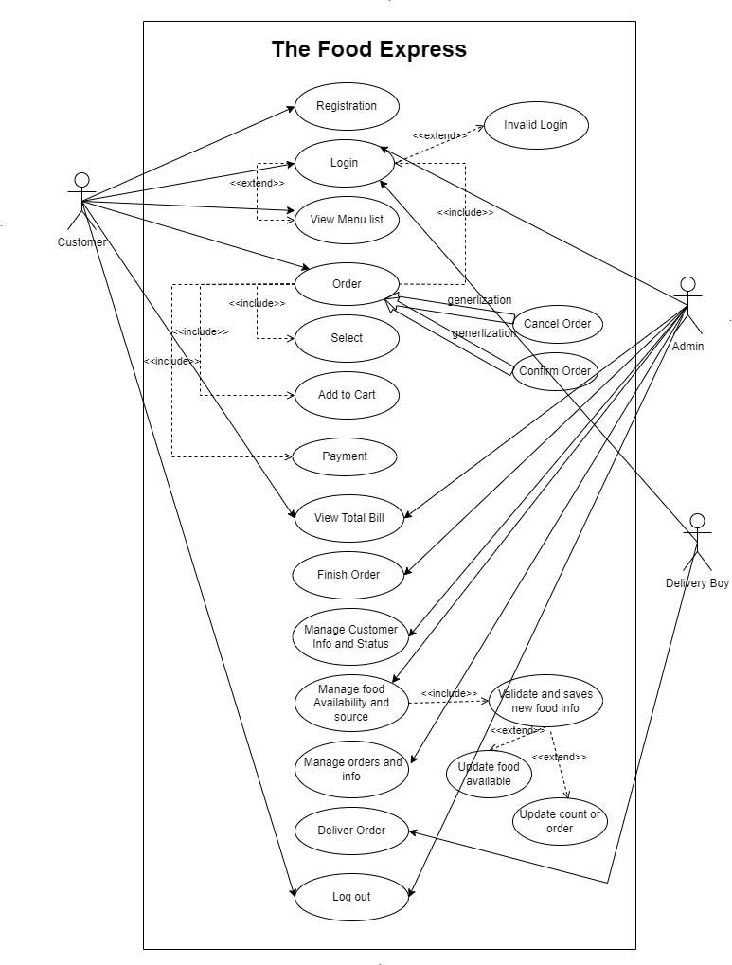
Figure. 3.1. Use case Diagram
Figure. 3.1. Shows the use case diagram of “The Food Express”, links between the use cases and their relationship with the other use cases. The relationship between login and the invalid login use case is extended because if the user put the correct username and password there will be no case of invalid login. To place the order customer must first login to the website so the relationship between login and order is included relationship. Similarly, all use cases are described in the above figure by their relation, and their arrows and link are detailed are given below.

3.2 Use case description
Use case diagrams to identify the interactions between the system and its actors. The use cases and actors in use-case diagrams describe what the system does and how the actors use it, but not how the system operates internally.

3.2.1 Actor:
Actors are defined as people, software, or some system that interacts with the web application. In this web application actors are
- Customer
- Admin • Delivery boy

3.2.1 Use case:
Function or operation write the name inside it. In this web application, some use cases are
• Login • Order • View menu list

3.2.3 Link:
Link “-” link, connect, or interact with the use cases.

3.2.4 Relationship:
It has three types.
- Generalization:
Relationship between parent and child use cases.
- <<Include>>
It is an implicit function that has mandatory steps carried out to accomplish a function. iii. <<Extend>>
It is an explicit function, steps taken by you as per the choice of optional function.

3.2.5 System:
The boundary box represents by a rectangle shape.

3.2.6 Actor:
Actors have two types.

I. Primary Actors:
Initiate the use of the system. It has a position on the left side of the system.
E.g. Customer

II. Secondary Actors:
More reactionary responses to the primary actor. It has a position on the right side of the system.
E.g. Admin

Table 3.1 Show the Detail of use case of Log in
Use case ID | UC-2
Use case name | View Menu
Description | The customer is able to view the restaurant menu on the website.
Trigger | Customer clicks on the "View Menu" button on the home page.
Precondition | Customer has access to the restaurant menu.
Post condition | The restaurant menu is displayed to the user.
Normal Flow | Step 1: User clicks on the "View Menu" button.  Step 2: Web application displays the restaurant menu to the user.

Use case ID | UC-1
Use case name | Log in
Description | Allows registered users to log in to their account. Otherwise, register yourself first.
Trigger | Customer clicks on the "Login" button on the website.
Precondition | Customer must have a registered account.
Post condition | Customer is logged in and can access their account information.
Normal Flow | Step 1: Navigate to the login page.  Step 2: Enter username and password.  Step 3: Verify username and password.  Step 4: Website create session for the user.  Step 5: Access the website as a logged-in user.

Table 3.2 Show the Detail of use case of View Menu

Table 3.3 Show the Detail use case of Place Order
Use case ID | UC-3
Use case name | Place Order
Description | Allows Customer to place an order by selecting food items from the menu, add to cart, specifying delivery details and payment options.
Trigger | Customer selects the "Place Order" option.
Precondition | Customer must be logged in and have selected items from the menu.
Post condition | The order is placed and the user receives a confirmation message.
Normal Flow | Step 1: User selects food items from the menu.  Step 2: User specifies delivery details, such as address and contact information.  Step 3: User selects payment option and provides payment details. Step 4: Web application calculates the total cost of the order and presents it to the user for confirmation.  Step 5: Customer confirms the order.  Step 6: Web application sends a confirmation message to the user and updates the order status.

Table 3.4 Show the Detail of use case of Payment

Use case ID | UC-4
Use case name | Payment
Description | This involves providing payment methods on deliver food and generating payment receipts and it should be physical.
Trigger | Customer have to pay for the food.
Precondition | Customer or admin must be place any order.
Post condition | Customer will receive a payment receipt.
Normal Flow | Step1: Customer first receive food. Step 2: Then it pay for the food .
Table 3.5 Show the Detail use case of Finish Order
Use case ID | UC-5
Use case name | Finish order
Description | The use case describes the process of finishing the order after the customer has received the food.
Trigger | The customer receives the food order.
Precondition | The customer has already placed and paid for the order.
Post condition | The order status is updated as "completed" and the customer is asked to provide feedback.
Normal Flow | Step 1: The customer receives the food and checks it.  Step 2: Then marks the order as "completed" on the website, after which they are asked to rate the food and provide feedback.

Table 3.6 Show the Detail of use case of Deliver Order

Use case ID | UC-6
Use case name | Deliver Order
Description | This use case describes the process of delivering an order to a customer.
Trigger | A delivery order is ready to be delivered.
Precondition | The delivery information is accurate and up-to-date.
Post condition | The order is successfully delivered to the customer.
Normal Flow | The delivery person reviews the order details and customer information.  The delivery person prepares the order for delivery.  The delivery person travels to the customer's location.  The delivery person confirms the customer's identity and delivers the order.  The delivery person updates the order status as delivered in the web application.
Table 3.7 Show the Detail of use case Manage Customer info and Status
Use case ID | UC-7
Use case name | Manage Customer Info and Status
Description | Allows admin to manage customer information and status
Trigger | Admin is logged in to the website. Admin selects the "Manage Customer Info and Status" option from the system menu.
Precondition | Admin is logged in to the system.
Post condition | Customer information and status are updated in the system.
Normal Flow | Step 1: Admin selects the customer they wish to manage.  Step 2: The website displays the customer information and status.  Step 3: Admin updates the information, status as necessary and the website saves the changes to the customer record.

Table 3.8 Show the Detail of use case of Manage Food availability and source

Use case ID | UC-8
Use case name | Manage food availability and source
Description | Allows admin to manage food information and status.
Trigger | Admin is logged in to the web application. Admin selects the "Manage food availability and source" option from the website menu.
Precondition | Admin is logged in to the system.
Post condition | Food available and source are updated in the website.
Normal Flow | Step 1: Admin selects the customer they wish to manage.  Step 2: The web application displays the customer information and status.  Step 2: Admin updates the information and status as necessary, the website saves the changes to the customer record.

3.9 Show the Detail of use case of Log Out
Use case ID | UC-9
Use case name | Log out
Description | Allows a user and admin to log out of the online food order website.
Trigger | Customer or admin chooses to log out.
Precondition | Customer or admin must be logged in to the website.
Post condition | Customer or admin is logged out of the website and returned to the login page.
Normal Flow | Step1: User or admin clicks on the "Log Out" button.  Step 2: Website logs the user out and returns to the login page.

4. Functional Requirements
Below Tables describe the functional requirements of “The Food Express” web application that are necessary to add to the project. Every functional requirement is defined by its identifier, title, Requirement, source, resource, dependencies and priority.

Table 4.1 functional requirement “User registration and login”

Identifier | FR_1
Title | User registration and login
Requirements | Allow users to register and login to web application with secure authentication, including registration fields for name, email, phone number, and password, and options for social media login.  No internet no development.
Sources | User data from registration and login, social media APIs for login options.  Use Visual Studio for development.
Resources | Secure database to store user information and credentials, server-side scripting for authentication and authorization, user interface for login and registration forms.
Dependencies | Integration with other functional requirements such as placing orders, managing user profiles, and processing payments.
Priority | High
4.2 functional requirement “Admin login”
Identifier | FR_2
Title | Admin login
Requirements | The website should allow admin login with username and password.
Sources | Admin login credentials are stored in the database.
Resources | Login page with input fields for username and password, and a submit button to authenticate the credentials.
Dependencies | The website should first check if the admin is registered and has correct login credentials.
Priority | High

Table 4.3 functional requirement “View Menu”

Identifier | FR_3
Title | View Menu
Requirements | The website must allow users to view the menu of available food items.
Sources | The menu information must be stored in the database.
Resources | The website should display the menu in an organized and user-friendly format, with options for filtering and searching.
Dependencies | The menu information must be kept up to date and synced with the availability of food items.
Priority | High
Identifier | FR_5
Title | Payment method
Requirements | Allow customer to pay for their order after food received.
Sources | Customer dashboard.
Resources | Database to store amount to be credit.
Dependencies | Customer authentication system.
Priority | High.
4.4 functional requirement “Place Order”
Identifier | FR_4
Title | Place Order
Requirements | Allow customer to browse menu items and add them to a cart. Allow customer to specify special instructions for their order.  Allow customer to select a delivery or pickup time.  Provide customer with an estimated delivery or pickup time.  Calculate and display the total cost of the order.  Allow customer to place the order securely.  Send an order confirmation email to the customer.
Sources | User input and interaction with the website.
Resources | Online platform, database, payment gateway, email service.
Dependencies | Availability of menu items, accurate pricing information, real-time inventory status, availability of delivery drivers.
Priority | High

Table 4.5 functional requirement “Payment method”

Table 4.6 functional requirement “Manage food availability”

Identifier | FR_6
Title | Manage Food Availability
Requirements | Allow admin to manage availability of food items.  Display current availability status of food items.
Sources | Admin dashboard.
Resources | Database to store availability status of food items.
Dependencies | Admin authentication system.
Priority | High.

Table 4.7 functional requirement “Manage Order and info”

Identifier | FR_7
Title | Manage order and info
Requirements | Allow admin to manage orders and order details.
Sources | Customer input, database records.
Resources | Order management system, database, admin interface
Dependencies | Admin registration/login, menu availability.
Priority | High

Table 4.8 functional requirement “Mange customer info and status”

Identifier | FR_8
Title | Only admin can manage customer info and status
Requirements | Ability to view customer information and order history.  Ability to update customer status and order status.  Ability to delete customer accounts and orders.
Sources | Customer feedback.  Market research.
Resources | Customer database.  Order database.  Admin dashboard.
Dependencies | Integration with the user registration and login module.  Integration with the place order module.
Priority | High

Table 4.9 functional requirement “Deliver Order”

Identifier | FR_9
Title | Deliver Order
Requirements | The website shall allow delivery personnel to view the list of pending delivery orders.  The website shall allow delivery personnel to update the status of delivery orders.  The website shall allow delivery personnel to mark a delivery order as completed.  The website shall provide an option for delivery personnel to view the delivery address and contact information of the customer.
Sources | User requirements  Business requirements  Delivery personnel feedback
Resources | Customer information database  Order management database
Dependencies | Order placement and processing  Customer information management
Priority | High

Table 4.10 functional requirement “Log out”

Identifier | FR_10
Title | Log out
Requirements | Customer should be able to log out of their account.
Sources | Customer interface.
Resources | Customer account information.
Dependencies | None
Priority | High

5. Non-Functional Requirements
“The Food Express” web application has both functional and non-functional requirements. Non-functional requirements specify how the web application should perform and behave, rather than what it should do. These requirements ensure that the web application has the necessary performance, security, reliability, and maintainability characteristics that meet the needs of the stakeholders. The non-functional requirements of “The Food Express” web application must be specific, quantitative, and verifiable, to enable proper testing and evaluation of the web application attributes. In this context, we will specify some non- functional requirements for the “The Food Express” web application.

5.1 Usability
- USE-1: “The Food Express” web application will have a user-friendly interface with intuitive navigation and clear labeling of all features to ensure ease of use for all customers.
- USE-2“The Food Express” ” web application will provide clear and concise instructions to guide users through the order process to ensure a smooth user experience.
- USE-3: “The Food Express” ” web application will provide an option for customers to switch to their food items according to their desired food.
- USE-4: “The Food Express” ” web application will ensure that all form fields and buttons are easily accessible for customers with disabilities, including those who know little use of technology.

5.2 Performance
- PER-1: “The Food Express” web application will be available 24/7 to ensure order access for customers.
- PER-2: “The Food Express” ” web application will have a response time of no more than 5 seconds for all customer interactions to system ensure a seamless customer experience.
- PER-3: “The Food Express” ” web application will be able to handle at least 10,000 concurrent customers to ensure scalability and performance during order times.
However, for this prototype, it might be less

6. References
- Google https://www.studocu.com/in/home
- Wikipedia https://en.wikipedia.org/wiki/Online_food_ordering#food_delivery_services
- OpenAI
https://www.upmenu.com/software-for-restaurants/integrations/developers/
- GeeksforGeeks https://www.geeksforgeeks.org/food-ordering-system-in-c/

